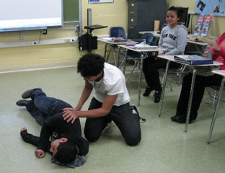
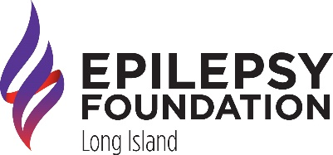
#EpilepsyEquity

#EndEpilepsy

You can now be certified in Seizure First Aid!

About Epilepsy
Epilepsy, also known as seizure disorder, is a neurological disease characterized by two or more unprovoked seizures occurring more than 24 hours apart. A seizure is a sudden surge of electrical activity in the brain, comes in many forms, and can affect consciousness, movement, and sensation.

About the Training
The Epilepsy Foundation is launching the first and only FREE Seizure Recognition and First Aid Certification training to support the 3.4 million people in the U.S. with epilepsy. This training provides information to increase the knowledge, skills, and confidence in recognizing seizures and safely administering seizure first aid. This program is part of the Epilepsy Foundation’s efforts to End Epilepsy® and ensure the safety and well-being of people with epilepsy.

What You Will Learn
- How to recognize signs of a seizure
- How to respond with proper seizure first aid
- When to call for help
Why should you know Seizure First Aid?
Seizures can happen anywhere and at any time. Knowing how to help someone during a seizure can make a difference and save a life. The Seizure First Aid Certification training provides information to increase the knowledge, skills and confidence in recognizing seizures and safely administering seizure first aid.

Who should be Seizure First Aid Certified?
Seizure First Aid Certification is designed for people who:
- Have a family member, loved one, or friend with seizures.
- Have a job where you provide care for people with seizures.
- Have a job where you work with the public or work with someone who has seizures.
- Coach or lead groups.
- Work, play or live in areas or settings where seizures could occur.

ZOOM
Next class: Wednesday, June 22, 2022
6:30 – 8:15 p.m.

Please see the instructions for Registration and For Taking the Mandatory Pre-Course
Knowledge Assessment on the reverse side of this flyer.

Seizure Recognition and First Aid Certification Instructions

STEP 1: Zoom Pre-registration is required. Please register at https://bit.ly/SFACERTJUNE22
After you register, you will receive an email confirmation including the zoom link for the June 22nd class.
To receive certification, you MUST complete STEP 2:
STEP 2: To receive certification, you must take a brief Pre-Course Knowledge Assessment:
- Each person must create an account in the Epilepsy Learning Portal at
learn.efa.org/SFA-Cert-ILT-CEP-v2
B. You should land on the page below. Please click on “Register for Live Session” in the purple box below the picture.
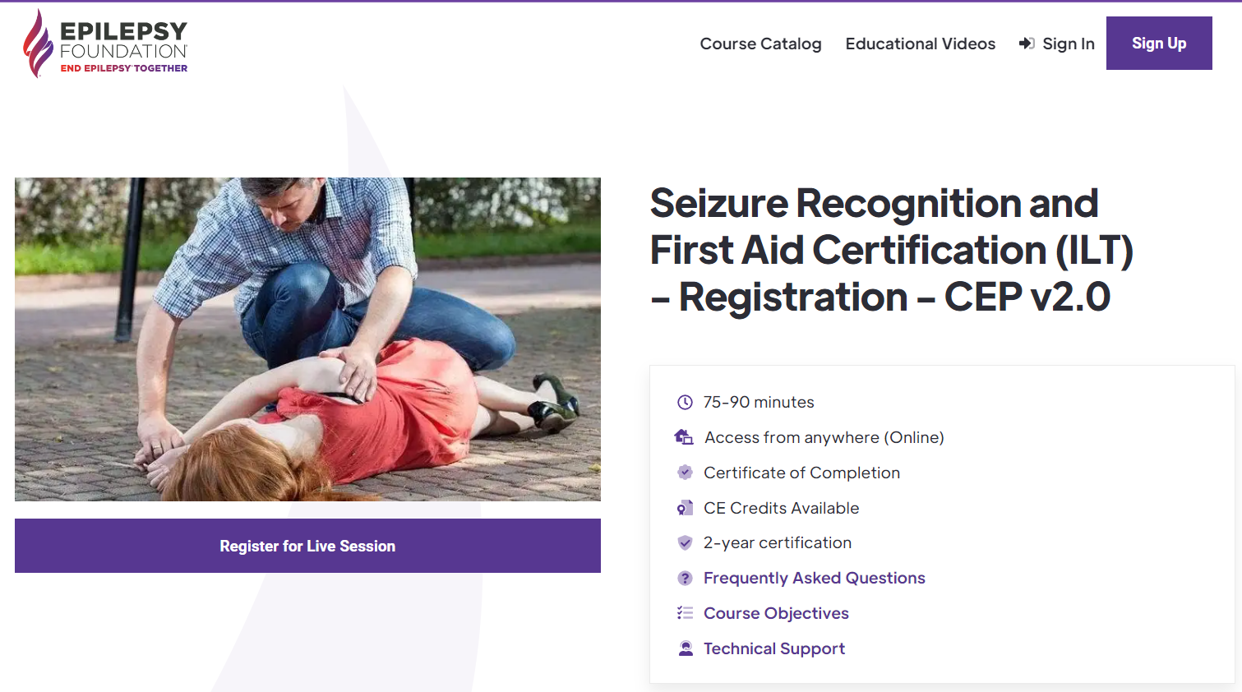
- On the next page, you will create your account
- Once your account is created you will come to the “Demographic Questions.” Please complete this section.
- Where it asks for the date of the training, please enter 06/22/2022
- Where it asks for who will provide the training, please type “Epilepsy Foundation Long Island.”
E. You will be directed to the Pre-Course Knowledge Assessment (Pre-Test).
Once you have taken the Pre-Test, do not go any further.
You are done with the Pre-Course Work Requirements.

SEE YOU ON JUNE 22, 2022 @ 6:30 PM on Zoom!
For questions or more information, please contact:
Janet Romeo (516) 739-7733, option 1, x 145 or jromeo@epicli.org

